Functional Specification

iPoS for Cambodia

Supplement

Version 0.3

Revision Summary

Version No. | Date | Revision Description | Author(s) | Approver(s)
V0.1 | 7/11/2016 | Draft version | Echo Quan
V0.2 | 11/11/2016 | Updated based on user comments. | Echo Quan
V0.3 | 11/22/2016 | Added Section 2.2.4, and Section 2.4.2 per user requirements. | Echo Quan

Approval / Signoff

Approver name and title | Function or Department | Signature or Email attachment | Signoff date

Distribution List

Company / Department | Person / Group

Table of Contents
Revision Summary 2
Approval / Signoff 3
Distribution List 4
1 Objective 6
2 Detailed functional descriptions 6
2.1 Activation and Login 6
2.2 Contact 6
2.2.1 Referral 6
2.2.2 Remark 7
2.2.3 Change of Name fields 8
2.2.4 Email and phone call 8
2.2.5 Quick link to add new quotation and new eAppilcation 8
2.3 Quotation 9
2.3.1 Pre-package plans for IS users 9
2.3.2 Return of Premium 10
2.3.3 e-Mail function 11
2.4 eApplication 11
2.4.1 CFF Information 11
2.5 Submission 12
2.5.1 e-Mail function for IS users 12
3 Reference 12

Objective
This document is the supplement to the Functional Specification for Cambodia v0.7.

Detailed functional descriptions

Activation and Login
One User can only do the activation and login to one specific iPad. This specific iPad ID is configured in Staging DB. The details will be included in iMO Wrapper FS.

Contact

Referral
After an eApplication is successfully submitted, at the completion page, there is a link “Referral Information”, when clicking this link, User goes to the Referral page. User can input the name and mobile number for the referrals he/she obtained.

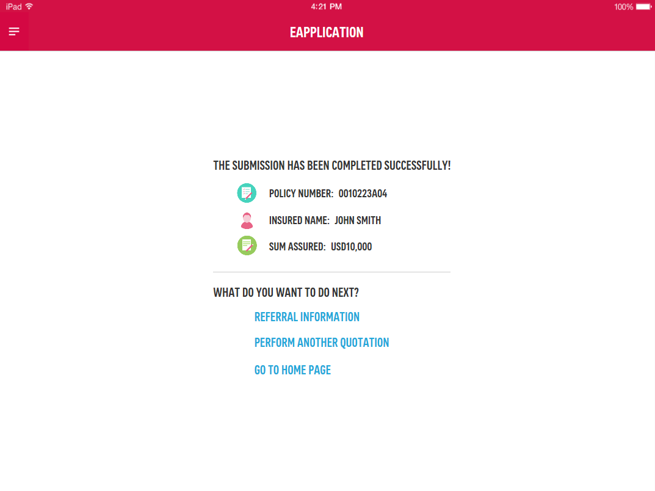
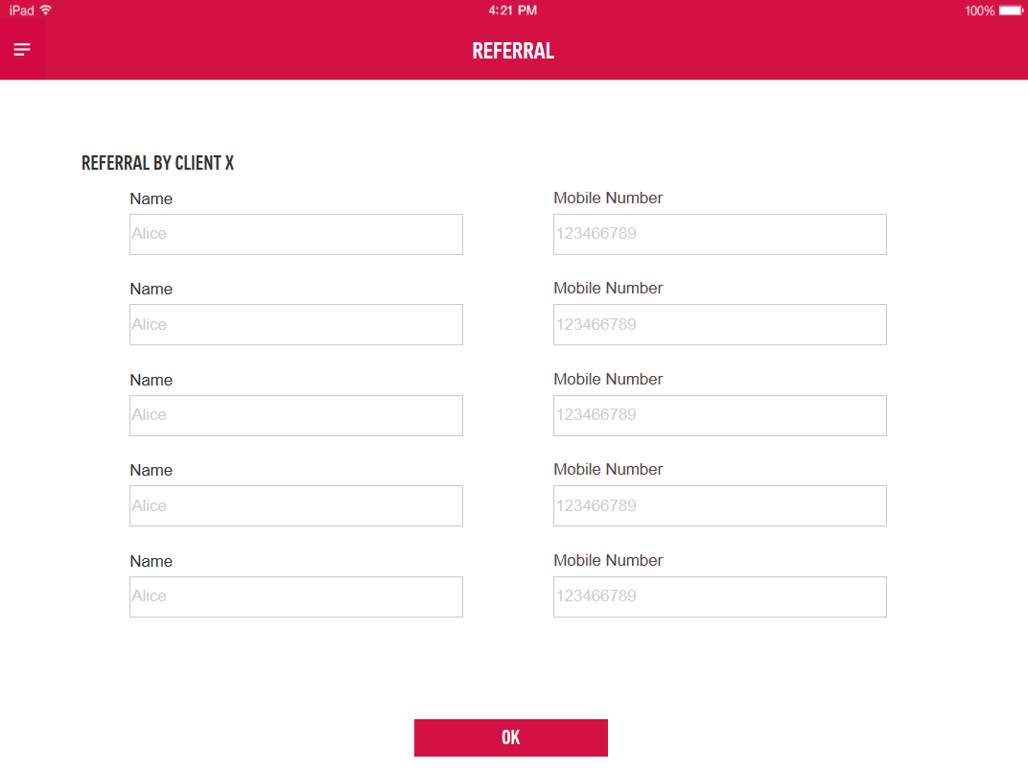
User can input 5 names and mobiles the most. The Name and Mobile Number fields follow the same validation as those in Contact modules.

After clicking OK, User goes to the home page of Contact module. The Names in Referral page will be created as contacts and listed as contact Cards. User can input other information required in the Contact Card anytime later.

This page cannot be accessed from other pages other than the successful submission page.

Remark
In the Basic Information page, User can input any contact under Remark field. This field is free text, and allow 500 characters the most.

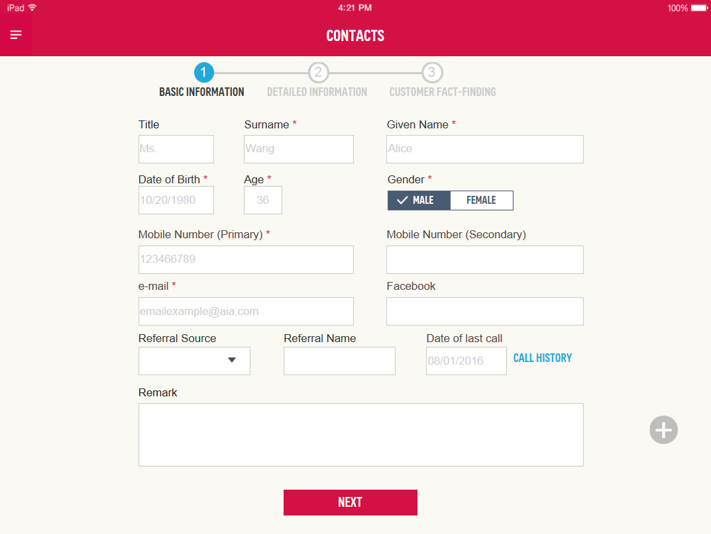

Change of Name fields
Change “Surname” and “Given Name” into “Name” for all fields within iPoS.

Email Function
Under the list view of Contact, when User clicks email address of the contact, email window will show up with the contact’s email address populated to allow User to send email directly.

Quick link to add new quotation and new eAppilcation
When User clicks the floating button “+”, System shows 4 quick links. User can click the links anytime.
- Add New Quotation: When clicking this link, User goes to the Payor and Insured Information page under Quotation module, information in Basic Information page will be brought to quotation automatically.
- Add New eApplication: When clicking this link, User goes to the Quotation Selection page under eApplication module.
- View Quotation List: When clicking this link, User goes to the quotation list page under Contact module, and view all the quotations made for this contact.
- View eApplication List: When clicking this link, User goes to the eApplication list page under Contact module, and view all the eApplications made for this contact.

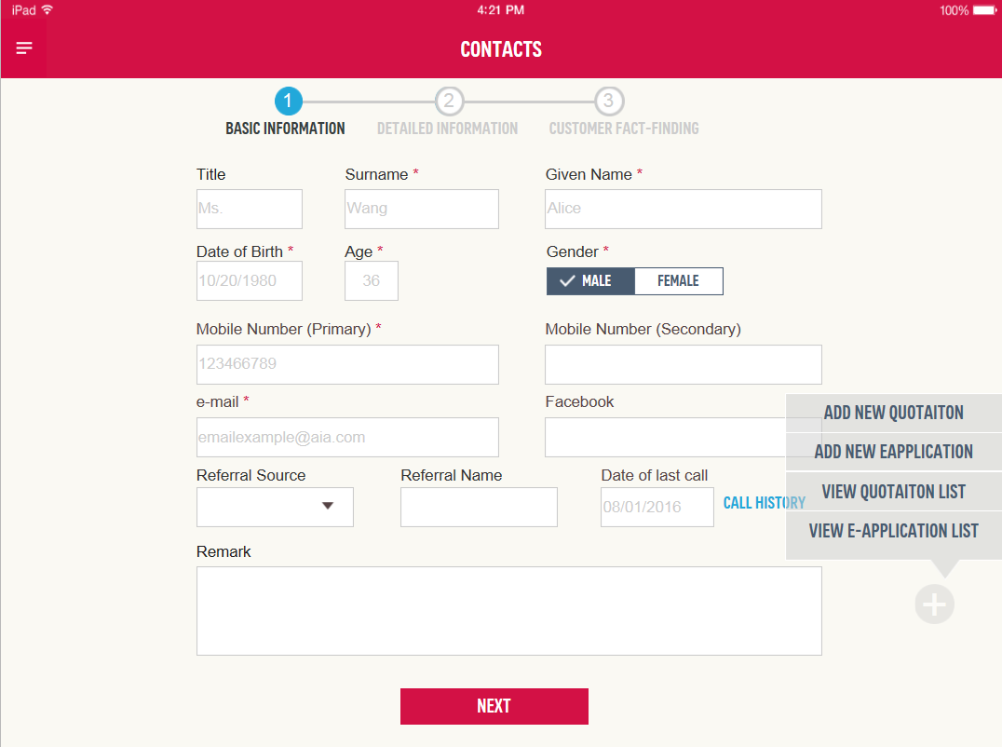

Quotation

Pre-package plans for IS users
For each product of Basic, Protection, Education, and Care, there are 3 pre-package plans. Each pre-package plan has fixed Sum Assured, Payment Term, Policy Term, Payment Mode, Riders, ROP. And they are not editable by User.
For Flexible product, all parameters are not pre-set, User needs to input or change them manually.

Pre-package plans are as attached (to be confirmed).


When IS users come to the Product page from Sales Presenter, the priority selected in Sales Presenter will determine which product has been selected. User can still change the pre-selected product if needed. Then after User clicks Next button, System shows 3 pre-package plans under the selected product. User can further select one of the pre-package plans to proceed.

When IS users come to Quotation module directly, not from Sales Presenter, which means the Priority is not set yet, then IS users can select either of the products freely, then select either of pre-package plans freely.
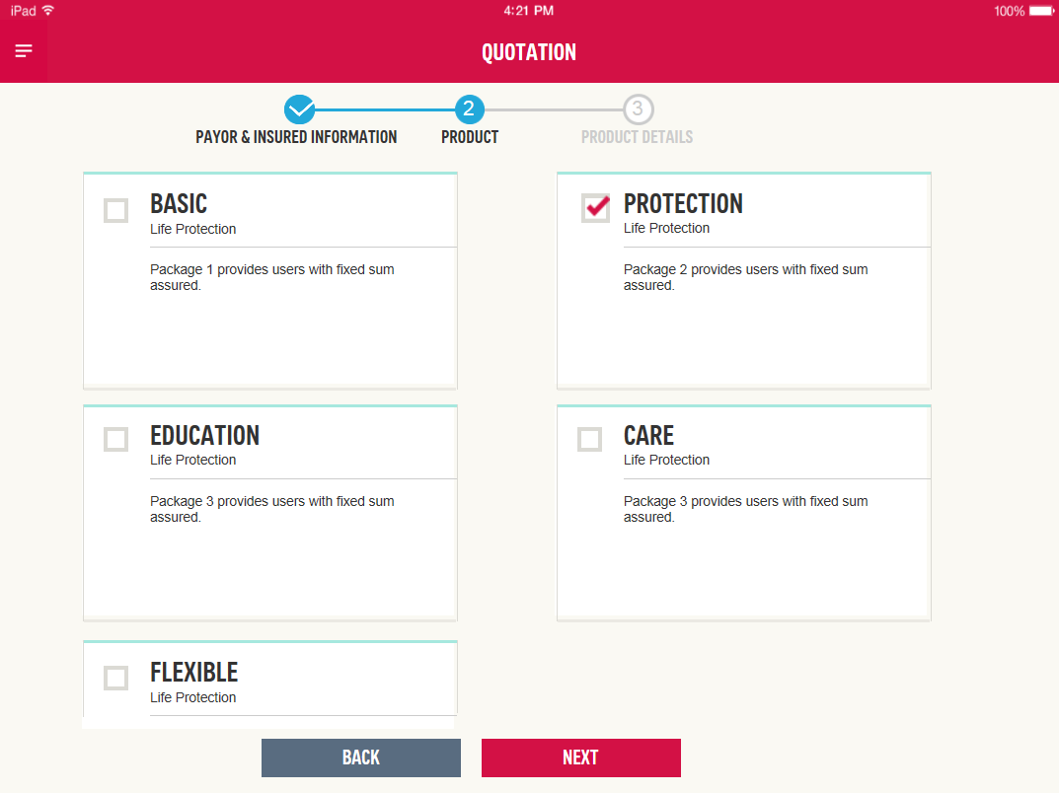 -> 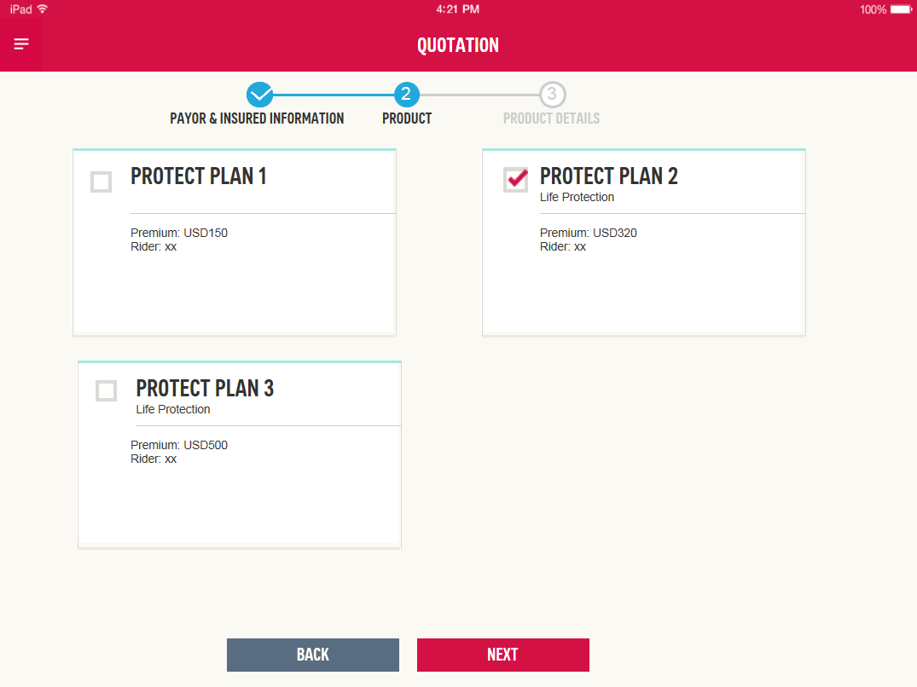

For Agent users, there will be no pre-package plans for selection. After Agent users selected the product, System goes to the Product Details page directly.

Return of Premium
Options of Return of Premium are 1-Basic Protection, 2-Money Back, 3-Money Back with Interest. By default, it’s set to 1-Basic Protection. For Flexi plan, it can be edited. For package plans, once the priority is confirmed, then ROP is confirmed and not editable.
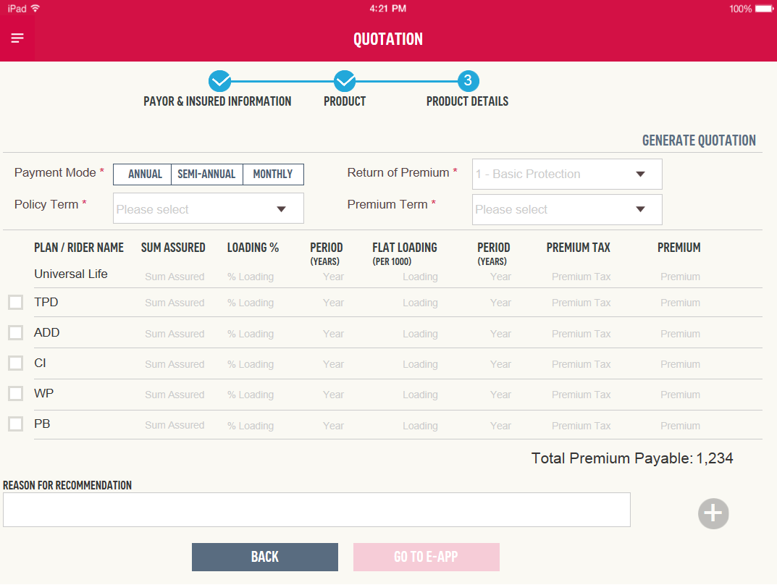

The mapping table between the priorities and ROP options is as below (to be confirmed).
Priority | ROP | Remark
Dying too Soon | 1 – Basic Protection | When User set this as the 1st priority, System selects ROP to 1 and it cannot be changed.
Living Death | 2 – Money Back | When User set this as the 1st priority, System selects ROP to 2 and it cannot be changed.
Children’s Future | 3 – Money Back with Interest | When User set this as the 1st priority, System selects ROP to 3 and it cannot be changed.
Wealth Creation | 3 – Money Back with Interest | When User set this as the 1st priority, System selects ROP to 3 and it cannot be changed.
Living Too Long | 3 – Money Back with Interest | When User set this as the 1st priority, System selects ROP to 3 and it cannot be changed.

e-Mail function
When the Quotation form is being sent out to a contact, an exactly same email will be sent to AIA operation team (email address to be confirmed) at the same time from User’s iPad, and this email won’t be viewed or edited by User.

eApplication

CFF Information
The tabs of Spouse Information and Child or Other Dependence are included, which are the same as the CFF step in Contact module, so that User doesn’t need to go back to contact module to complete the required information. CFF Information in both Contact and eApplication modules are auto synchronized.

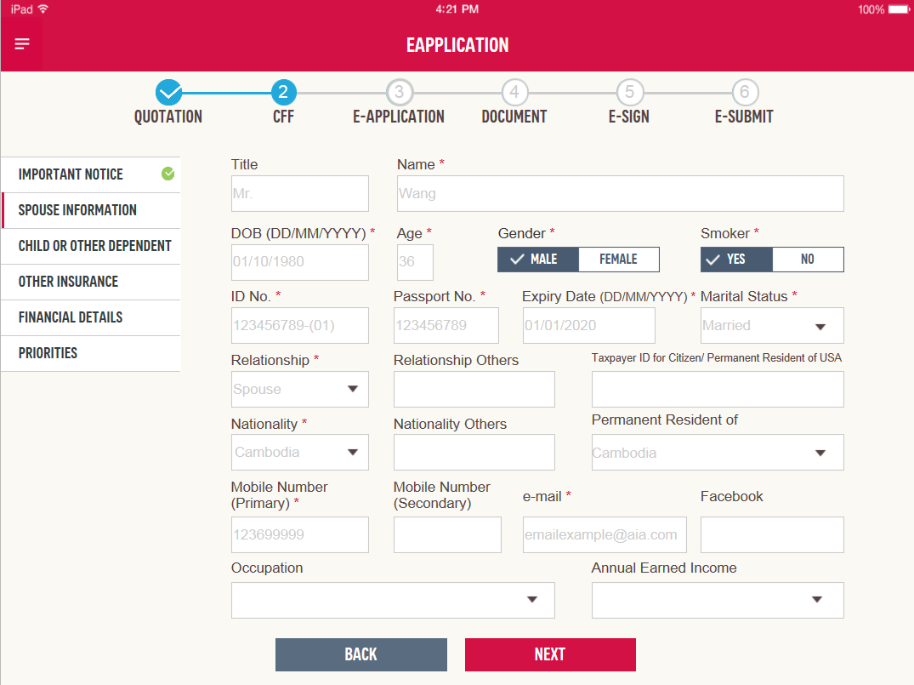

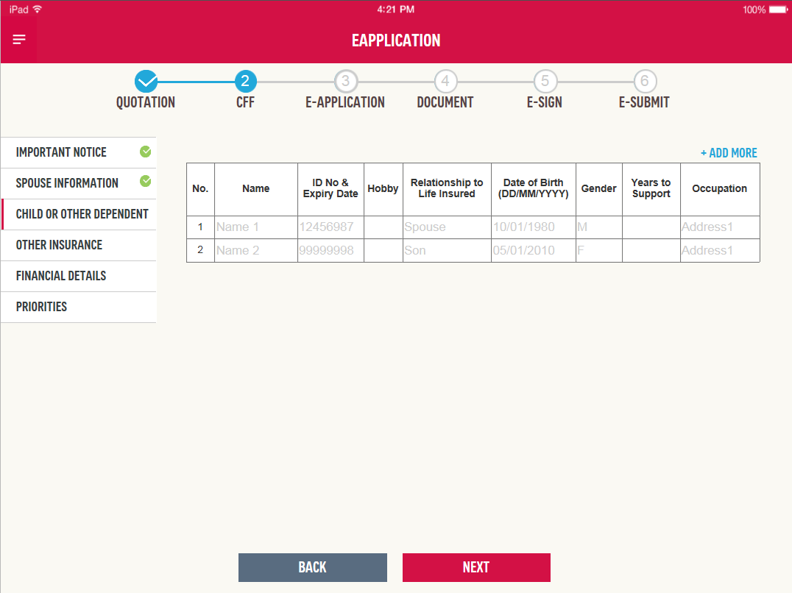

Payment Method
There are 4 Payment Methods for User selection, they are Auto Pay, Direct Pay, Credit Card, and eSI (electronic Standing Instruction).

When choosing Auto Pay, or Direct Pay, no further information are not required.

When choosing Credit Card, User needs to provide below information.
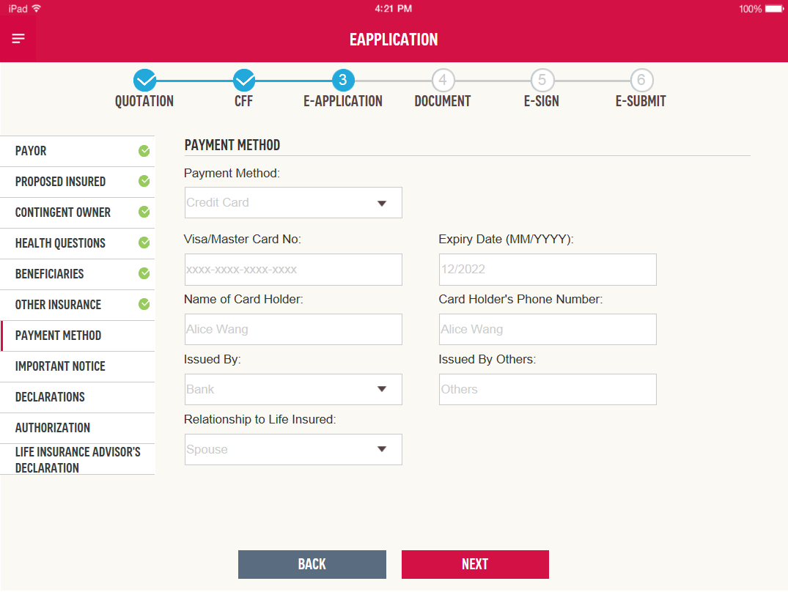

Field Name | Type/Length | Value/Format | Validation | Mandatory (Y/N) | Remark
Visa/Master Card No. | Numeric | xxxx-xxxx-xxxx-xxxx | Validation rules to be provided | Y
Expiry Date | Date | MM/YYYY |  | Y
Card Holder Name | Text |  |  | Y | This will not create a new contact
Issued By | Dropdown |  |  | Y
Issued By Others | Text |  |  | Y* | Others is selected in Issued by field
Relationship to Life Insured | Dropdown | Male / Female |  | Y
Card holder’s Phone Number | Numeric |  |  | N

When choosing eSI, User needs to provide account number and amount.

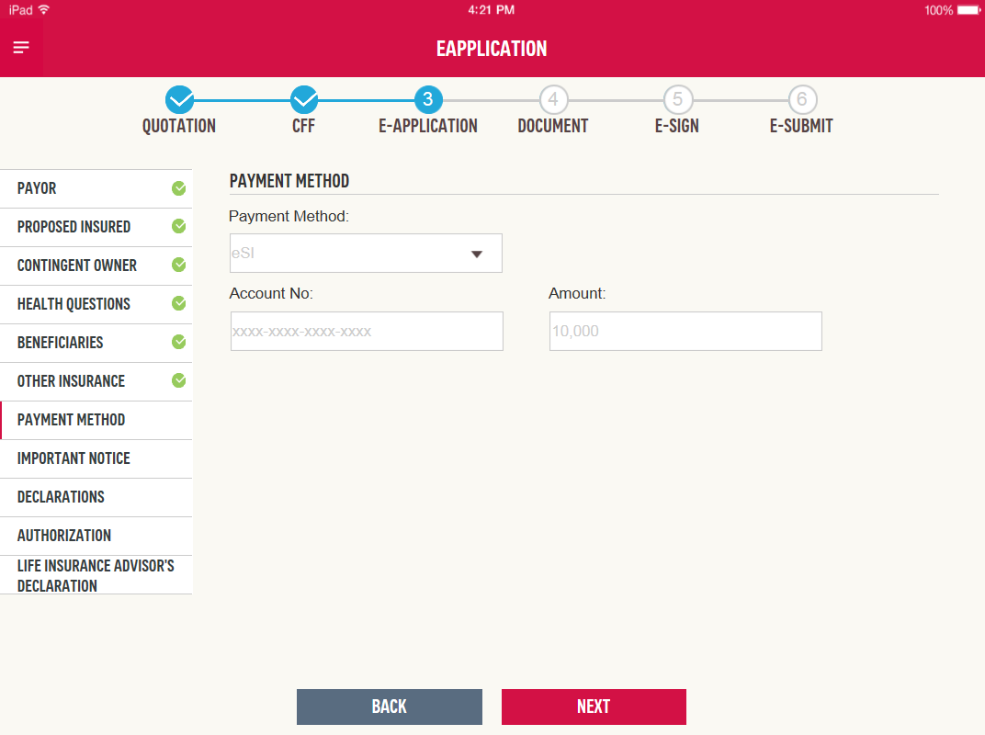

Field Name | Type/Length | Value/Format | Validation | Mandatory (Y/N) | Remark
Account No. | Numeric | xxxx-xxxx-xxxx-xxxx |  | Y
Amount | Numeric |  |  | Y

Meanwhile, eSI form will be generated at e-Submit step and signature is required on the eSI form. (eSI form to be provided.)
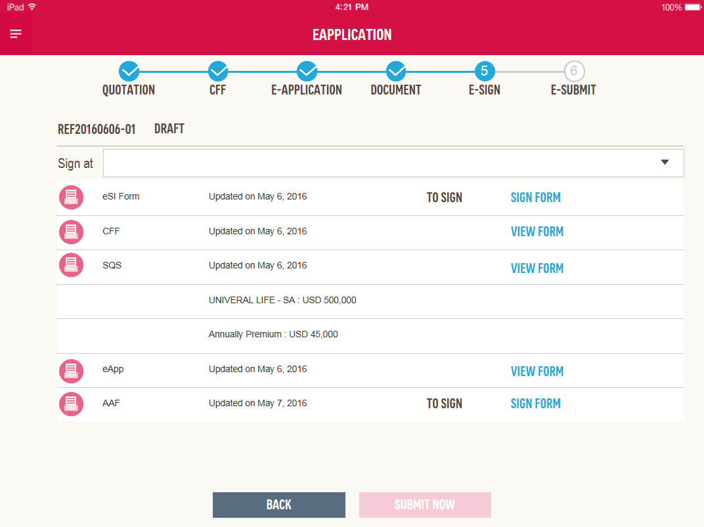

Submission

e-Mail function for IS users
When an eApplication is successfully sent to Staging, and the Policy Number has returned to iPoS, Staging will send out an email to the contact. Meanwhile, this email will be copied to AIA and Bank email address as well. Email contents and AIA/Bank email address to be provided.

If the email sending out by staging is interrupted due to connection issue, or other reasons, it should be able to be sent out again when the Internet connection is resumed.

Document Naming Convention
PDF files and image files are stored in local device and staging, with below naming convention:

Policy No_Folder Type_ Document Type_Submission Date

e.g. 0001234A01_NB_Life Application Form_20161121
0001234A01_NB_ID_20161121

Reference
- Functional Specification for CAM iPoS v0.7

